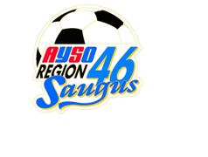COACHES SELF NOMINATION FORM
If you are interested in coaching an All Star or Tournament Team please submit your name using the form below. Your completed form must be received by your division representative no later than October 19, 2021. In addition, please email a copy to Rene Ornelas at RORNELAS.RO@gmail.com and Steve Grover at aysoregion46arc@gmail.com. Candidates will be reviewed by the Executive Board and placed on the ballot if approved.
If you have any questions, please do not hesitate to contact Steve Grover at the above mentioned email address.
-----------------------------------------------------CUT & SAVE top portion ---------------------------------------------------
Division representative: Deliver to Rene Ornelas & Steve Grover
Coach Self Nomination Form
COACH NAME_________________________________________
Coach phone number ________________________ Coach E-mail________________________________
I currently coach: ___Girls ____ Boys Division ___9U ___10U___11U ___12U ___13U ___14U___16U ____19U
My Coach Certification Level is:
___10U ___12U ___Intermediate ___Advanced
I have completed ____ AYSOs Safe Haven completed within the last two years and ___ CDC Concussion Training within the current year
I wish to be considered for balloting for the following:
____Coaching All Stars ____Coaching Tournament Division _____ Girls or Boys

* With the self-nomination, coaches agree they will abide by the guidelines set forth by the Region. A meeting to go over the said guidelines will be scheduled after coaches have been approved.

